31 .Aim :To Design PDA using simulator to accept the input string anbn

INPUT:

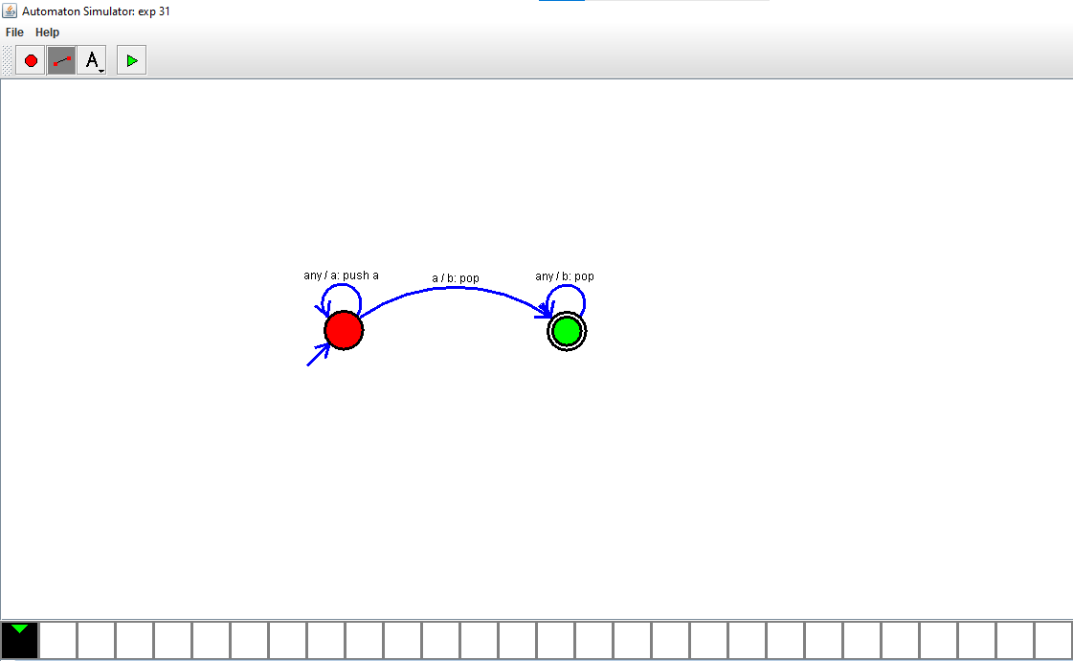

OUTPUT:



RESULTS:Thus Designed PDA using simulator to accept the input string anbn